CLASS : S.E. COMP SUBJECT : DEL

EXPT. NO. : 8 DATE :

TITLE : SEQUENCE GENERATOR CIRCUIT

OBJECTIVE :

- Design and Implement the following Sequence generator circuit using IC-74LS76 and verify its truth-table.
Sequence: ( )

APPARATUS :
Digital-Board, GP-4 Patch-Cords, IC-74LS76, IC-74LS32, IC-74LS04/IC-74LS08 and Required Logic gates if any

THEORY :
Sequence Generator is a Sequential Logic circuits which can be use to generate the Pre-determined sequence. Sequence Generator is classified into two categories: Sequential Sequence Generator & Non-Sequential Sequence Generator. Ring Counter can be constructed using IC-74LS76.In case of Ring Counter output of last Flip-flop is connected to the J_{A} input of First Flip-Flop and complementary output of Last Flip-Flop is connected to K_{A} Input of First Flip-Flop. Output of first flip-flop (Q_{A}&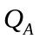) is connected to the inputs of second flip-flop (J_{B} & K_{B}) and so on. And connect set & reset pin to Vcc.

PIN Diagram :

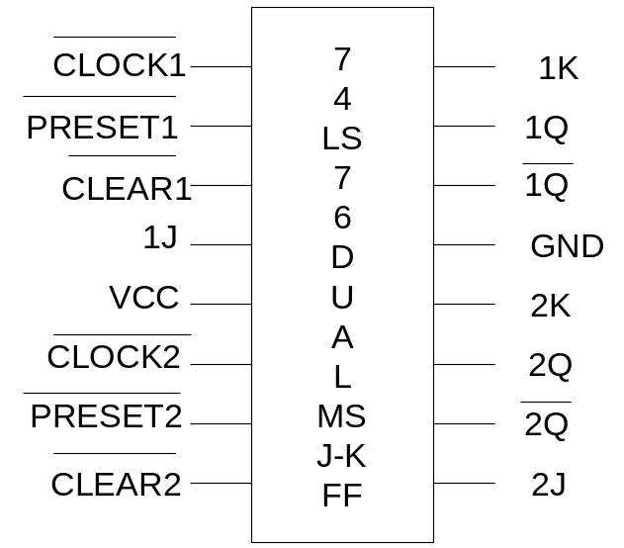

PROCEDURE :

- Make the connections as per the Logic circuit of Sequence generator circuit using IC-74LS76 and Verify its Truth Table.

Design of Sequence Generator circuits with Lockout condition

Dec.Equ. | PRESENT STATE |  |  | NEXT STATE |  |  | INPUT
Dec.Equ. | Q_{A} | Q_{B} | Q_{C} | Q_{A}⁺ | Q_{B}⁺ | Q_{C}⁺ | J_{A} | K_{A} | J_{B} | K_{B} | J_{C} | K_{C}

K-Map Simplification for J_{A} , K_{A} , J_{B} , K_{B} , J_{C} , K_{C}
Logic diagram:

Design of Sequence Generator without Lockout Condition

Dec.Equ. | PRESENT STATE |  |  | NEXT STATE |  |  | INPUT
Dec.Equ. | Q_{A} | Q_{B} | Q_{C} | Q_{A}⁺ | Q_{B}⁺ | Q_{C}⁺ | J_{A} | K_{A} | J_{B} | K_{B} | J_{C} | K_{C}
K-Map Simplification for JA , KA , JB , KB , JC , KC
Logic Diagram:
Logic Gates / MSI Device required for Implementation:

Sr.No. | Title | Name of the IC | Number of Gates required | IC  Required
01 | Sequence Generator with lockout condition
02 | Sequence Generator with lockout condition

CONCLUSION:

REFFRENCE:

- R.P.Jain “Modern Digital Electronics” TMH 4th Edition
- D.Leach,Malvino,Saha,”Digital Principles and Applications”,TMH

Subject teacher Sign with Date Remark

